**Student Portal**

1. Go to Bibb county webpage

[www.bcsdk12.net](http://www.bcsdk12.net)

Click on Parents tab

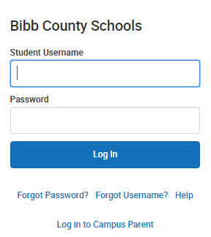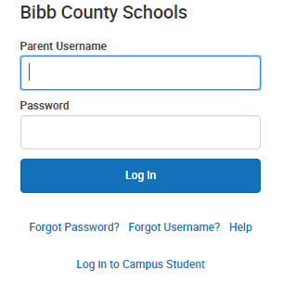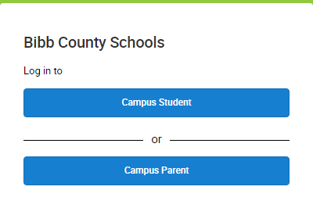

Note. If a student cannot access their account, please email [campushelp@bcsdk12.net](mailto:campushelp@bcsdk12.net) for assistance.

4. Students will type in their username and password

* Username is the student’s lunchroom number
* Password is the student’s first initial>last initial>six digit birth date

2. Click Parent Portal

3. Students click on Campus Student