GA FTE Verification and Processing

FTE / Student Class Check List

Count 3
Date of Count: 03/07/2019
Fiscal Year: 2019
Report #: 1

The following data elements must be entered for ALL students in your school, even if enrolled only one day.

DEMOGRAPHICS
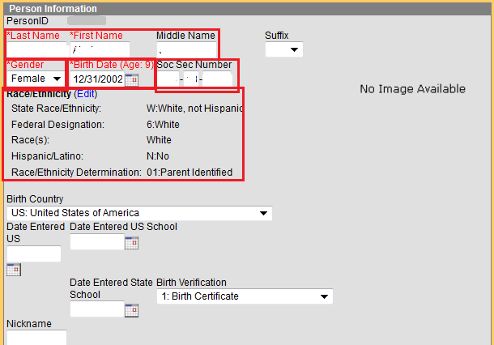

- All students have Social Security Number or a state assigned 999 number.
Change only if the number entered is incorrect. Do not change a 999# to a SSN. Correct in GUIDE!

To verify you have no missing Social Security Numbers:
- Click Ad Hoc Reporting.

Click Data Export.
- Click the + sign beside the FTE icon.
- Scroll to the Query, ‘Copy of Missing SS’ and click to highlight.
- Click Comma Separated Values.
- Click Prompt to Save File
- Click Export.
- Click OPEN.

- All students have GTID number. Claim Student if you have not already done so.

To verify you have no missing GTID Numbers:
- Click Ad Hoc Reporting.

Click Data Export.
- Click the + sign beside the FTE icon.
- Scroll to the Query, ‘Missing GTID Numbers’ and click to highlight.
- Click Comma Separated Values.
- Click Prompt to Save File
- Click Export.
- Click OPEN.

- Student name includes First, Middle and Last names and matches exactly the name as listed on the students Birth Certificate. If student has no middle name, or only a middle initial, please verify that in the ‘Student Middle Name Verification’ field at the bottom of the Demographics page.

To verify full names entered:
- Click Ad Hoc Reporting.

Click Data Export.
- Click the + sign beside the FTE icon.
- Scroll to the Query, ‘Student Full Names’ and click to highlight.
- Click Comma Separated Values.
- Click Prompt to Save File
- Click Export.
- Click OPEN.

- All students have correct birth date.

- Click Ad Hoc Reporting.
- Click Data Export.
- Click the + sign beside the FTE icon.
- Scroll to the Query, ‘Student Birth Date’ and click to highlight.
- Click Comma Separated Values.
- Click Prompt to Save File
- Click Export.
- Click OPEN.

Run the following to find missing birthdates:
- Click Ad Hoc Reporting.
- Click Data Export.
- Click the + sign beside the FTE icon.
- Scroll to the Query, ‘Student Missing Birth Date’ and click to highlight.
- Click Comma Separated Values.
- Click Prompt to Save File
- Click Export.
- Click OPEN.
If in doubt, verify birthdate in Infinite Campus with the student’s Birth Certificate.

- All students have correct gender code.

- Click Ad Hoc Reporting.
- Click Data Export.
- Click the + sign beside the FTE icon.
- Scroll to the Query, ‘Student Gender’ and click to highlight.
- Click Comma Separated Values.
- Click Prompt to Save File
- Click Export.
- Click OPEN.

- All students have all parts for race/ethnicity code.

All three areas must be entered.

- Is the student Hispanic/Latino
Hispanic or Latino
Not part of race indicators. Identifies Hispanic ethnicity. For definition, refer to the Data Element Detail document

An ethnicity flag that is used to identify a person of Cuban, Mexican, Puerto Rican, South or Central American, or other Spanish culture or origin, regardless of race.
The term “Spanish Origin” can be used in addition to “Hispanic/Latino or Latino.”

(NOTE: This ethnicity indicator is separate from the race indicators.
Individuals shall have the opportunity to identify themselves as being of or belonging to more than one race. If an individual identifies more than one race, and also flags ETHNIC HISPANIC as yes, that person is counted as Hispanic.

- Individual from one or more of these races?

One of the five race indicators that can be set to yes or no for a student. More than one can apply.

2 - American Indian or Alaska Native
A person having origins in any of the original peoples of North and South America (including Central America), who maintains a tribal affiliation or community attachment.
3 – Asian
A person having origins in any of the original peoples of the Far East, Southeast Asia, or the Indian subcontinent including, for example, Cambodia, China, India, Japan, Korea, Malaysia, Pakistan, the Philippine Islands, Thailand, and Vietnam.
4 - Black or African American
A person having origins in any of the original peoples of the Black racial groups of Africa.
5 - Native Hawaiian or Other Pacific Islander
A person having origins in any of the original peoples of Hawaii, Guam, Samoa, or other Pacific Islands.
6 – White
A person having origins in any of the original peoples of Europe, the Middle East, or North Africa.
7 – Multiple selection

- Race/Ethnicity Determination?
01: Parent Identified
02: Student Identified
03: Observer Determined
04: Unknown

    - Click Ad Hoc Reporting.
    - Click Data Export.
    - Click the + sign beside the FTE icon.
    - Scroll to the Query, ‘Race/Ethnicity missing’ and click to highlight.
    - Click Comma Separated Values.
    - Click Prompt to Save File
    - Click Export.
    - Click OPEN.

- All students have a Birth Country/Birth Place.
All students not born in any US state, District of Columbia or Puerto Rico has the Date of Entry into US School. This includes students of military personnel born in another country.

Children born to U.S. parents on military bases are U.S. citizens. The PLACE OF BIRTH (which should be on the birth certificate) may reflect their actual country of birth. Report the PLACE OF BIRTH based on the information shown on the birth certificate (or other approved documentation listed policy guidelines). The new definition of born in the U.S. allows the student to be counted as an immigrant for purposes of Title III immigrant children and youth program, provided they meet the full definition of an immigrant student.

DATE OF ENTRY TO U.S. SCHOOLS is the date the student first enrolled in school in the United States. This date is required if the student was born outside the United States. It is optional for students born in the U.S., who left the country prior to attending school and are subsequently enrolling in a U.S. school. Under Section 3301(14), a student is considered “born in the U.S.” if born in one of the 50 States, the District of Columbia, or the Commonwealth of Puerto Rico. DATE OF ENTRY TO U.S. SCHOOLS is required for International Exchange Students.
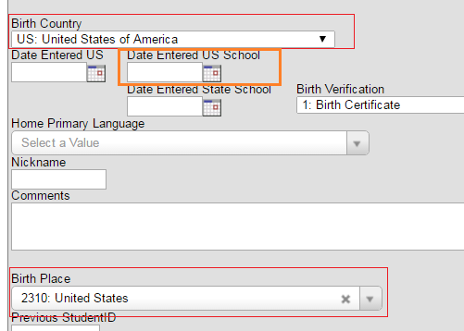

To verify Birth Country:
  - Click Ad Hoc Reporting.
  - Click Data Export.
  - Click the + sign beside the Student Records icon.
  - Scroll to the Query, ‘copy of Birth Country’ and click to highlight.
  - Click Comma Separated Values.
  - Click Export.
  - Click OPEN.

To correct Birth Country:

- Click plus (+) sign by Census
- Click People
- Search for Student
- Click the student to select
- On the Demographics page, click the dropdown under Birth Country.
- Select appropriate country.
- Click the Dropdown under Birth Place and select the appropriate country.
- SAVE

To correct Date Entered US /Date Entered US School:

- Click plus (+) sign by Census
- Click People
- Search for Student
- Click the student to select
- On the Demographics page, click in the date by Date Entered US/ Date Entered US School.
- Enter the date in the mm/dd/yy format.
- Click Save

- All students not born in the US (2310) or Puerto Rico (1790) must have their primary spoken language entered if the student is coded EL = ‘Y’. Primary Language cannot be Blank if the student is an English Learner.

- Click Ad Hoc Reporting.

Click Data Export.
- Click the + sign beside the Student Record icon.
- Scroll to the Query, ‘’Home Primary Language’ and click to highlight.
- Click Comma Separated Values.
- Click Prompt to Save File
- Click Export.
- Click OPEN.

- All must have the language preference for written communication entered if the student is coded EL = ‘Y’. Primary Language cannot be Blank if the student is an English Learner.

- All Students enrolled in U.S. School Less Than 3 Years has been coded in Enrollment
U.S. SCHOOL LESS THAN 3 YEARS indicates whether the student has been enrolled in a U.S. school for less than 3 years (i.e., accumulated 36 months). The accumulated school months are based on enrollment periods. For example, a student may be enrolled in the U.S. for one year, then leave the country for a year, then return to the U.S. and re-enroll. The 36 months would not include the time the student was out of the country. The months do not need to be consecutive months, just cumulative months.

- All students have the appropriate grade level entered. Verify there are no underage Kindergarteners or underage 1st graders.

- Click Ad Hoc Reporting.

Click Data Export.
- Click the + sign beside the FTE icon.
- Scroll to the Query, ‘Correct Grade’ and click to highlight.
- Click Comma Separated Values.
- Click Prompt to Save File
- Click Export.
- Click OPEN.
Enrollment Information

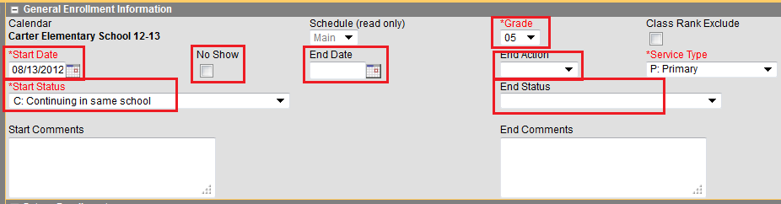

- Start Date is a valid school day (08/01/18 or Greater).

- Click Ad Hoc Reporting.

Click Data Export.
- Click the + sign beside the FTE icon.
- Scroll to the Query, ‘Correct Start Date’ and click to highlight.
- Click Comma Separated Values.
- Click Prompt to Save File
- Click Export.
- Click OPEN.

- Verify your enrollment codes.

Code Description
‘A’ – Admitted from home school
‘B’ – Re-entered after previously withdrawing this school year
‘C’ – Continuing in the same school
‘I’ – Re-entered after incarceration
‘N’ – Never attended school before
‘O’ Transferred from another state or country
‘P’ – Transferred from private school
‘R’ – Re-entered Other
‘S’ – Re-entered after illness
‘T’ – Transferred from another Georgia public school system
‘U’ – Transferred or promoted within the same school system
‘V’ – Admitted under SB10
‘W’ – Admitted under School Choice
‘X’ - Admitted under USCO
Indicates the most recent reason the student entered school this school year. The SCHOOL ENTRY CODE for International Exchange Students must be ‘O’.

- Click Ad Hoc Reporting.

Click Data Export.
- Click the + sign beside the FTE icon.
- Scroll to the Query, ‘Copy of Enrollment Codes’ and click to highlight.
- Click Comma Separated Values.
- Click Prompt to Save File
- Click Export.
- Click OPEN.

NOTE: The default enrollment code is C – please verify the student is actually continuing in your school from last year. If they were in another school you must correct it.

- Student Environment Code
Review those on list. If all 3 areas are not marked, verify with Dr Danielle Jones that the students are homeless.

Type of residential environment in which the student resides
Must equal one of the following codes:
‘1’ – Resides in a local institution for the neglected
‘2’ – Resides in a local institution for the delinquent
‘3’ – Is homeless
‘4’ – Unaccompanied Youth
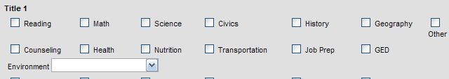

- Homeless and Homeless Primary Night Shelter is coded for all homeless students

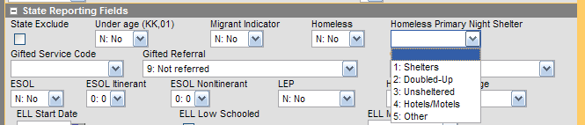

- All Students receiving gifted services this year has been coded in the Gifted Service Code field in Enrollment Information.

- Students receiving EIP Services have Early Intervention Services marked as Yes and the subject in which they are receiving EIP services has been entered.

EIP Subject Code indicates what academic subject(s) the student received Early Intervention Program services at any time during the school year. An EIP SUBJECT CODE should be reported for all students with an FTE program code of ‘E’ ‘F’ or ‘G’. (Kindergarten, Primary Grades, 4th and 5th Grades) Codes ‘1’-‘3’ valid only for GRADE LEVEL KK-05.

EIP Subject Code has been entered for any student receiving EIP services at any time this year.

To verify EIP Subject Code
- Click Ad Hoc Reporting.
- Click Data Export.
- Click the + sign beside the Student Records icon.
- Scroll to the Saved Filter, ‘Copy of EIP Subject Code’ and click to highlight.
- Click Delimited Values(CSV)
- Click Export.
- Click OPEN.

Give this list to your EIP teacher to verify.

To correct EIP Subject Code:
- Click Student Information
- Click General
- Search for Student
- Locate desired student
- Click Enrollment Tab
- Open the 15-16 line of enrollment
- Change/update Remedial Education/EIP.
- Save

- REP Subject Code has been entered for any student receiving REP services at any time this year. Courses are coded as .1 only are remedial ed courses.

REMEDIAL ED SUBJECT CODE indicates the academic subjects for which the student received Remedial Education Program (REP) services at any time during this school year. Code the student for Remedial Education Program (REP) services received at any time during this school year. These codes are valid for students in grades 6-12 ONLY.
To verify REP Subject Code
- Click Ad Hoc Reporting.
- Click Data Export.
- Click the + sign beside the Student Records icon.
- Scroll to the Saved Filter, ‘Copy of REP Subject Code’ and click to highlight.
- Click Delimited Values(CSV)
- Click Export.
- Click OPEN.

To correct REP Subject Code:
- Click Student Information
- Click General
- Search for Student
- Locate desired student
- Click Enrollment Tab
- Open the 18-19 line of enrollment
- Change/update Remedial Education/EIP.
- Save

- Resident District, Resident County, Residence Status
NOTE: the Resident District and the Resident County must be the same.

To verify:
- Click Ad Hoc Reporting
- Click Data Export
- Click the + sign beside the FTE icon
- Scroll to the Query, ‘Residence/Status’ and highlight
- Click Comma Separated Values
- Click Prompt to Save File
- Click Export
- Click OPEN

  - Resident District has been entered in Enrollment Information for all students. Bibb County residence is 611.

  - Resident County has been entered in Enrollment Information for all students.

  - Residence Status has been entered in Enrollment Information for all students.
To correct Resident information:
- Click Student Information
- Click General
- Search for Student
- Locate desired student
- Click Enrollment Tab
- Click the 16-17 line of enrollment
- Click the drop down for Resident District / Resident County / Residence Status and select appropriate district.

Code | Description | Includes
1 | Resident of your school system | Both Foreign Exchange and homeless students are considered residents of the school system in which they are enrolled.
2* | Nonresident, in-state, with consent of the system to accept this student with or without tuition | Children of employees who do not reside in the  school system, but who are allowed to enroll their  children should have RESIDENT STATUS CODE = “2”.  These students are funded through FTE.
7 | Non-Resident, Consent - International Exchange Student | International Exchange Students on a J-1 or F-1 visa should have a RESIDENT STATUS CODE = ‘7’.

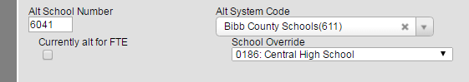
- Alternate System Code/Alternate School Code – All students attending a program outside their zoned school must have the Alternate System Code and the Alternate School Code entered in the Enrollment Tab.

- All students enrolled in a .7 class has the Category of WBL Program entered in Enrollment

Valid values for CATEGORY OF WBL PROGRAM are:
'C' = Cooperative Education
'I' = Internship
'G' = Great Promise Partnership
'E' = Employability Skills Development
'Y' = Youth Apprenticeship Program
Blank

To locate students in a .7 class:
- Click Ad Hoc Reporting
- Click Data Export
- Click the + sign beside the FTE icon
- Scroll to the Query, ‘WBL Program - Students scheduled for .7 class’ and highlight
- Click Comma Separated Values
- Click Prompt to Save File
- Click Export
- Click OPEN

To correct Resident information:
- Click Student Information
- Click General
- Search for Student
- Locate desired student
- Click Enrollment Tab
- Click the 18-19 line of enrollment
- Click the drop down for Category of WBL Program and select appropriate district.

Special Education

- All special ed students must have entered:
- Special Ed Status
- Area of Exceptionality
- Special Ed Environment

Area of Exceptionality

CODE |  | DESCRIPTION | CODE |  | DESCRIPTION
P | Mild Intellectual Disability |  | Y | Other Health Impairment
Q | Moderate Intellectual  Disability |  | Z | Visual Impairment
R | Severe Intellectual Disability |  | 1 | Blind
S | Profound Intellectual  Disability |  | 2 | Deaf and Blind
T | Emotional and Behavioral  Disorder |  | 3 | Speech-Language Impairment
U | Specific Learning Disability |  | 6 | Autism
V | Orthopedic Impairment |  | 7 | Traumatic Brain Injury
W | Hearing Impairment |  | 8 | Significant Developmental  Delay
X | Deaf |  | BLANK | N/A

• PRIMARY AREA = '8' must have GRADE LEVEL = 'PK', 'KK', 'UK', 'U1’, ‘01’, ‘02’, ‘03’, ‘04’ or ‘05’.
• PRIMARY AREA = '8' must have DATE OF BIRTH such that the student is less than 10 years of age as of September 1.

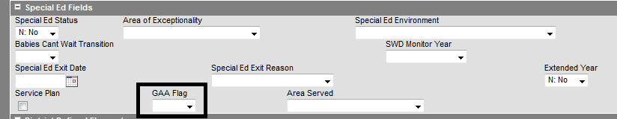
- GAA flag, in the Special Ed section of Enrollment Information is marked for all students who will take the GAA this school year. This information is used to generate labels for the GAA assessment

Courses

- All Courses are active and valid courses as indicated in the State-Funded List of K-8 Subjects and 9-12 Courses.

- Verify all students in a gifted course (XX.2) are gifted Eligible

  - Click Ad Hoc Reporting.

Click Data Export.
  - Click the + sign beside the FTE icon.
  - Scroll to the Query, ‘Students in .2 courses w/Eligibility’ and click to highlight.
  - Click Comma Separated Values.
  - Click Prompt to Save File
  - Click Export.
  - Click OPEN.

Gifted Eligiblity
2: | Initial eligibility this year
3: | Initial eligibility previous year
4: | Referred this year, not eligibile
9: | Never eligibile

- Gifted Delivery Model and Gifted Content Area for ALL Gifted sections have been entered into the Gifted Delivery Model and the Gifted content Area in each Gifted section.
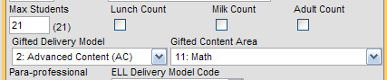

  - Click Ad Hoc Reporting.

Click Data Export.
  - Click the + sign beside the FTE icon.
  - Scroll to the Query, ‘Copy of Gifted Delivery Model/Content’ and click to highlight.
  - Click Comma Separated Values.
  - Click Prompt to Save File
  - Click Export.
  - Click OPEN.

EIP Delivery Model

- EIP Delivery Model for ALL IEP sections have been entered into the EIP Delivery Model. Verify Delivery model in the FTE Viewer.

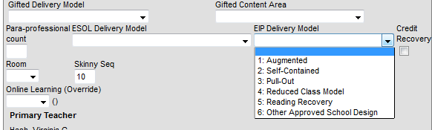
  - Click Ad Hoc Reporting.

Click Data Export.
  - Click the + sign beside the FTE icon.
  - Scroll to the Query, ‘EIP Classes w/delivery model’ and click to highlight.
  - Click Comma Separated Values.
  - Click Prompt to Save File
  - Click Export.
  - Click OPEN.

ESOL

- Delivery Model for ALL ESOL sections have been entered into the ESOL Delivery Model.

  - Click Ad Hoc Reporting.

Click Data Export.
  - Click the + sign beside the FTE icon.
  - Scroll to the Query, ‘ESOL Delivery Models’ and click to highlight.
  - Click Comma Separated Values.
  - Click Prompt to Save File
  - Click Export.
  - Click OPEN.

Online Classes

- All Online sections, including GAVS and E2020 (Edgenuity) has the ‘Online Course?’ Field set to Yes.

To set the Online Course? Field to Yes:

- Click Search tab.
- Search for a Course/Section.
- Search for desired Course.
- Open section for that course
- Click the Drop-Down under Online Course? and select Yes.
- Click Save
- Repeat for all sections of that course

To verify all have been set to yes:

- Click Ad Hoc Reporting.
- Click Data Export.
- Click the + sign beside the student records icon.
- Scroll to the Query, ‘Copy of Online Course’ and click to highlight.
- Click Delimited Values (CSV).
- Click Export.
- Click OPEN.

- Primary Teacher for Online Courses, including GAVS and E2020, has the Primary Teacher as one of the following based on the type of instruction the students are receiving in the section:
- Online, Self/Facilitated Instruction
- Online, Direct Instruction

- All Students in a .9 class are receiving special ed services and have a primary disability entered.

  - Click Ad Hoc Reporting.

Click Data Export.
  - Click the + sign beside the FTE icon.
  - Scroll to the Query, ‘Students in .9 courses and click to highlight.
  - Click Comma Separated Values.
  - Click Prompt to Save File
  - Click Export.
  - Click OPEN.

- All Students in a .8 class are receiving special ed services and have a primary disability entered

  - Click Ad Hoc Reporting.

Click Data Export.
  - Click the + sign beside the FTE icon.
  - Scroll to the Query, ‘Students in .8 courses and click to highlight.
  - Click Comma Separated Values.
  - Click Prompt to Save File
  - Click Export.
  - Click OPEN.

- Inclusion Code has been entered into the Inclusion code field on the Roster Batch Edit tab in the section which the student received Inclusion services.

INCLUSION CODE indicates that a student with disabilities has an individualized education program (IEP) that identifies the general education classroom as the least restrictive environment for the delivery of special education services for that course. INCLUSION includes both supportive instruction and direct special education services provided in the general education classroom. has been verified for all special ed students receiving supportive services.

1. Supportive Services – Students should be scheduled in a XX.0 class. Students receiving supportive services should be entered in the Inclusion field in Roster Batch Edit in the section they receive those services.

Code | Personnel Type | Description
4 | Paraprofessional | Personnel employed and/or assigned to provide assistance to students with disabilities in the general education classroom. Paraprofessionals provide educational services for a student with disabilities under the supervision of a professional. Paraprofessionals may perform their duties in environments where the following are provided: classroom instruction; physical education; speech-language instruction; vocational programs; community-based instruction, and other types of support to classroom instruction and related services. Paraprofessionals not providing services in the general education classroom are not reported with an inclusion code.
5 | Interperter | Personnel employed and/or assigned to facilitate communication between  students who are deaf or hard-of-hearing by interpreting from spoken English to American Sign Language (or the reverse) from spoken English to American Sign Language (or the reverse) and/or transliterating from spoken English to an English system used on the hands.
6 | Job Coach | Job Coach Personnel employed and/or assigned to teach, support and supervise (i.e., “coach”) specific jobs or components of jobs to students with disabilities in a community setting. This includes CTI serving students on the day of the count that are participating in CTAE Work-Based Learning Programs.
7 | Assistive or other personnel | Assistive or other personnel – Personnel other than Job Coaches, Interpreters, or Paraprofessionals who are employed and/or assigned to provide assistance to students with disabilities in the least restrictive educational environment.  Examples may include therapy or mobility aides.

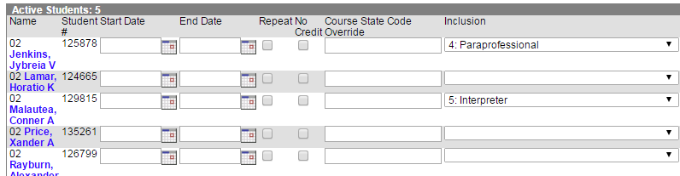

2. DIRECT SPECIAL EDUCATION INSTRUCTION
This indicates an instructional model where a special education teacher works with identified students and the general teacher within the general education classroom. Students receiving special education services in a general education setting through direct special education services are reported with a disability specific PROGRAM CODE and funded at Special Education Levels 1-4 with a disability-specific weight for FTE funding.
Students should be scheduled into a XX.9 class

Code | Personnel Type | Description
9 | Certified Specified Education Teacher / Co-Taught / Collaborative / Consultative Model | A general and special education teacher teaching in the same classroom with the special education teacher being in the classroom at least 50% of an instructional segment for collaborative and 100% of an instructional segment for co-taught. See SPECIAL EDUCATION requirements for reporting consultative services

The process will be run for all students placed in a XX.9 class to enter the Inclusion code.

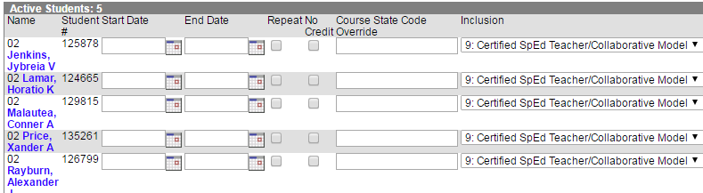

- Teacher of Record and co-teachers have been added to .9 classes.
Primary teacher is the content area teacher in both the .0 class and the .9 class
The Special Ed co-teacher is the additional teacher in both the .0 class and the .9 class.

  - Click Ad Hoc Reporting.

Click Data Export.
  - Click the + sign beside the FTE icon.
  - Scroll to the Query, ‘XX.9 classes w teacher & Co-teacher’ and click to highlight.
  - Click Comma Separated Values.
  - Click Prompt to Save File
  - Click Export.
  - Click OPEN.

Reporting Special Education Courses with Inclusion Services

XXXXX.0 | XX.8 | XX.9
Student does not require special education services in the segment  OR  Student receives inclusion  services during the segment  (inclusion codes 4-8)  • 4 - Paraprofessional  • 5 - Interpreter  • 6 - Job Coach  • 7 - Assistive or Other  Personnel  • 8 - General Ed Teacher | Student is in a separate class taught in a special education setting by a special education teacher. It may be a resource or self-contained class.  An inclusion code is not valid with a XX.8 class. | Student is in a general education setting taught by a general education teacher, and receives special education services through collaborative, co- teaching, or consultative models (inclusion code 9)  • 9 - Certified Special  Education Teacher

- All classes that meet on the day of the count has been verified for every section.
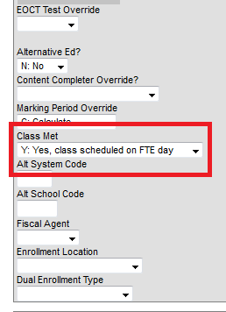

  - Click Ad Hoc Reporting.

Click Data Export.
  - Click the + sign beside the FTE icon.
  - Scroll to the Query, ‘Class Met day of count’ and click to highlight.
  - Click Comma Separated Values.
  - Click Prompt to Save File
  - Click Export.
  - Click OPEN.

- All teachers and additional teachers have been verify for every section.

  - Click Ad Hoc Reporting.

Click Data Export.
  - Click the + sign beside the FTE icon.
  - Scroll to the Query, ‘All Classes with Teachers and additional teacher’ and click to highlight.
  - Click Comma Separated Values.
  - Click Prompt to Save File
  - Click Export.
  - Click OPEN.
FTE Segments

- It is very important to not have any segments marked with an O (letter O not number 0) or any segments left blank. Segments marked with O or blank receive no funding. This could be a potential loss of funds earned for your school.

The only time an elementary school should have a segment marked with an O is for PK students. The only time a middle school should have a segment marked with an O is for a student that does not stay at school all day. The only time a high school should have a segment marked with an O is for the very few concurrent students.

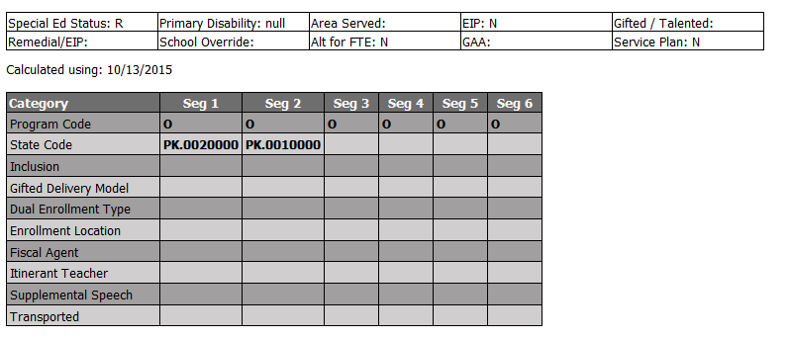

To Check ‘O’ Segments

- Click Ad Hoc Reporting.

Click Data Export.
- Click the + sign beside the FTE icon.
- Scroll to the Query, ‘Copy of FTE O Segments’ and click to highlight.
- Click Comma Separated Values.
- Click Prompt to Save File
- Click Export.

If any students are identified, check the student’s schedule and correct as necessary.

- Segments for Gifted students served on the day of the count have been marked with an ‘I’ on the FTE Calculations. If students are receiving gifted services but do not have the ‘I’ segment code, please correct schedule to show students are in Gifted Courses.

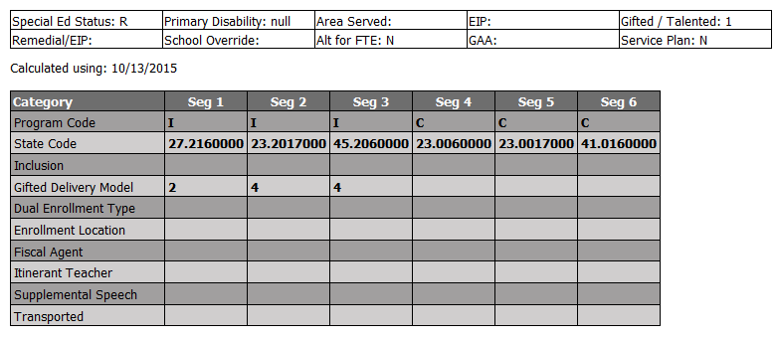

- Students EIP segments have been verified as correct
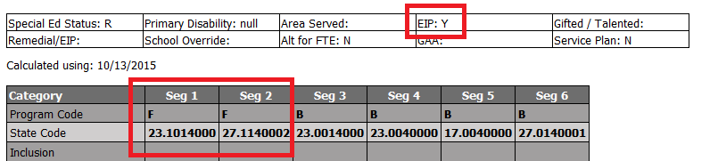
NOTE: EIP = Y, Seg 1 and Seg 2 = F

  - Segments for EIP Kindergarten students have been marked with an E in the FTE Calculations

  - Segments for EIP students, grade 1-3, have been marked with an F in the FTE Calculations

  - Segments for EIP students, grades 4-5, have been marked with a G in the FTE Calculations

  - Early Intervention Services field has been coded to ‘Yes’

  - Remedial Education/EIP field coded with the subject(s) for which they are receiving services.

- REP (Remedial Education) Grades 06-12 only – Can report only 2 ‘J’ segments.

  - Segments for students receiving remedial services have been coded with a ‘J’ in the FTE Calculations in Enrollment History

  - Remedial Education/EIP field coded with the subject(s) for which they are receiving services.

- Verify all sections are at or below maximum class size.

- All teachers have their SSN entered in the Demographics tab in Census/People

- Paraprofessionals and additional classroom teachers, assigned to provide support to the entire class, have been entered in the Para-professional Count in each section that has a parapro
