Posting 3rd 9 Week Progress Report Grades in Grade Book

Elementary School

The following must be completed for all sections in your grade book:
Step 1: Preparing for posting
- Verify you are in Campus Instruction. If needed, click on the app switcher and select Campus Instruction.
- From the action bar on the left side of the screen, click Gradebook
- Verify all Uncategorized Assignments from Canvas have been assigned a grading task and category.
- All Assignments have been placed in the Semester Avg spreadsheet.
Step 2: Posting Term 3 Progress Report Grade
- Select the desired spreadsheet by selecting options in the Term, Section and Task drop-down lists above the gradebook.
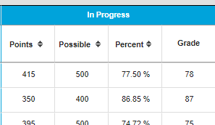
- Verify grades have been calculated in the ‘In Progress’ area of your spreadsheet. If not, you need to contact CampusHelp.

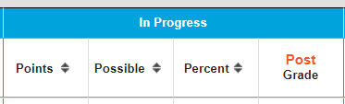
- Click the Post button in the In Progress section.

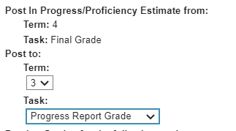
- A box will open that allows the teacher to indicate where the grade should be posted. Only the tasks open for posting will be available.
- Click dropdown under Term and select the Term 3, if needed.
- Click the dropdown under Task and select the Progress Report Grade
- Click OK, at the bottom of the window.
- You will automatically be taken to where your grades were posted and receive the following message: “Grades will be posted upon save”. Click OK
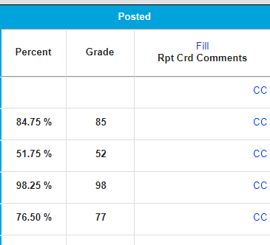
- You will see grades posted in the POSTED area of the Progress Report Grade spreadsheet.
- CLICK SAVE.

Step 3: Adding Conduct Grade and Comments
Comments will only print if they are entered in the same spreadsheet where grades have been given. We recommend adding comments into the ‘Homeroom’ or ‘Supervision’ course along with the Conduct grade.
Comments can be added to academic classes, if desired.

- Change to your desired Section, Term:1, Task: Conduct

- You must first make sure you have selected the option in Settings/Preferences and checked Use Canned Comments.

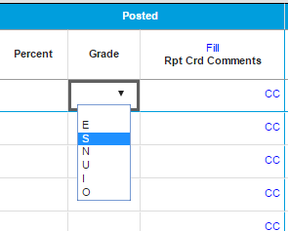
- Enter the Conduct Grade of E,S, I, or O in the drop-down under Grade in the Posted area

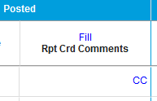
- Click on the cc in the Rpt Card Comments column in the Posted area.
- The Canned Comments window will open. If you wish to add a personal comment, you can type it in the Report Card Comment area.
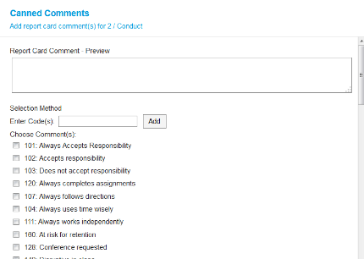
- To add a canned comments, you can either enter the code(s) number and click Add or check the box by the comment you are selecting and click Add Comments
- If you want the same comment for all students, you can click the Fill link above the Rpt Crd Comments. WARNING, do this before adding individualized comments.
- Click SAVE.

